**UDEMY PROJECT DESCRIPTION, FINDINGS AND RECOMMENDATIONS**

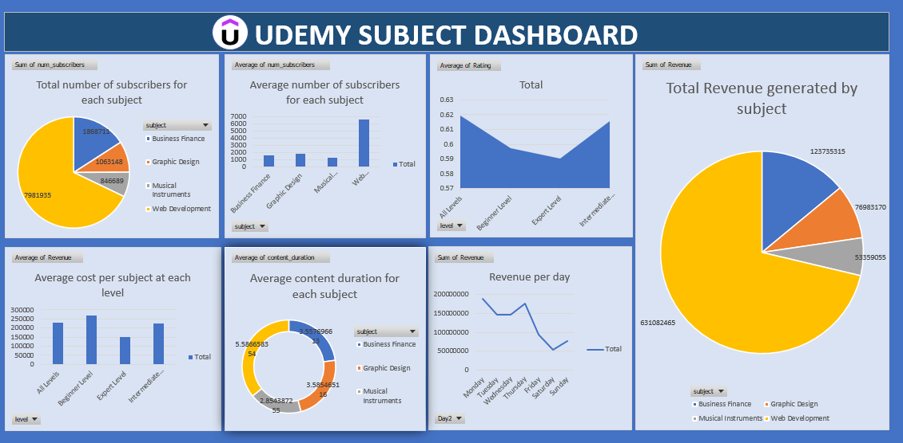

**INSIGHTS & FINDINGS**

From the analysis carried out on the Udemy datasets, the following findings were noted:

* Web development had the highest number of subscribers while Musical Instruments had the lowest number of subscribers as shown on the dashboard.
* Web development also had the highest content duration.
* Monday had the highest revenue generated from the subscribers.
* Finally, from the overall performance, Web development generated the most revenue.

**RECOMMENDATIONS:**

From the insights generated from the analysis, the following recommendations can be considered.

* The company channel more resources on Web development since it generates the most revenue.
* Also, most subscription were made on Monday; therefore, the company should increase its advert and sales on Mondays since that is when subscribers visit the company’s page most.